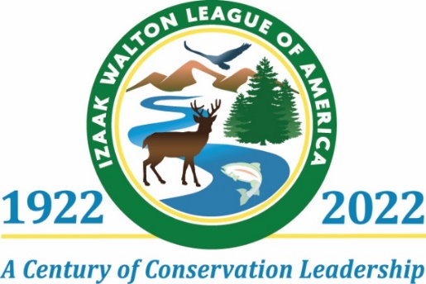

[Chapter press release template for contacting local media. Please fill in with chapter information and share with local reporters. For assistance with text or press lists, contact Michael Reinemer at national headquarters: mreinemer@iwla.org or 301-548-0150 ext. 220.]

[Date]

[Chapter Name] Looks Back at 100-Year Legacy of Izaak Walton League, Looks Forward to the Next 100

[CITY, STATE--- date] ----- The [Chapter Name] of the Izaak Walton League has provided conservation and outdoor recreation activities for local residents since it was founded in [year].

[Describe some of the activities conducted over those years.

Mention any upcoming activities or events of interest to the public. How to join, etc.

Describe the chapter’s hopes / plans for the future]

Throughout its 100-year history, the Izaak Walton League’s chapters have served as the place where kids caught their first fish, tried their hand at shooting sports or found their own way to appreciate nature.

Nationally, the Izaak Walton League has more than 200 chapters and thousands of members and supporters who champion community-based conservation, outdoor traditions and protection of the nation’s natural resources.

The chapters have provided the backbone for many conservation achievements over the past century, whether restoring bass populations in streams during the 1920s, promoting ethical hunting in the 1950s or serving as recycling hubs in the 1970s. The chapters also advanced some of the most effective conservation ideas in the nation’s history, like the Land and Water Conservation Fund, shaping the laws and policies that protect natural resources now and for generations to come.

History of the National Organization
In January 1922, a group of concerned anglers and hunters gathered in Illinois to create an organization to stop the degradation of America’s waterways and natural areas. They named the organization after Izaak Walton, the conservationist and author of The Compleat Angler.

During the 1920s, industrial pollution, raw sewage and soil erosion threatened many of the nation’s rivers. Forests and other wild areas were also suffering as road building, development, and commercial hunting and fishing took an immense toll.

For 100 years, the League has been at the forefront of local and national efforts to safeguard water resources and our drinking water across the U.S. – from a push for sewage treatment in the 1930s to the landmark Clean Water Act of 1972, which tackled pollution and protected wetlands.

The League has also created thriving volunteer citizen science programs like Save Our Streams and Salt Watch to monitor stream health and collect data about water quality. By collecting and reporting data in dozens of states, these programs now provide a wealth of information for scientists and policymakers and a basis for taking action to protect water quality.

For many decades, the League has also served as a leader in conserving the natural resources on the hundreds of millions of acres of agricultural land in the U.S. Beginning in 1937, the League began a push for a national program to conserve soil.

In short, no other organization has done more to shape the nation’s bedrock laws that protect our environment and natural resources. The League has a unique role in promoting conservation and citizen science locally while advocating for strong state and national policies to protect our air, water and wildlife.

For millions of people, the League has provided a pathway to outdoor recreation and traditions.

Looking to the future, the Izaak Walton League has ambitious goals to get more Americans involved in local conservation, citizen science and advocacy.

Chapter Press Contact:
[List names, emails, phone numbers of chapter members who can help journalists get more information or answer questions]

