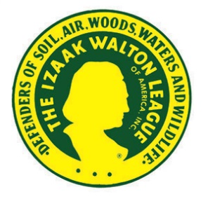
MEDIA ALERT
DATE

Izaak Walton League XX Chapter Brings Community Together
To Stop Water Pollution

WHO: | XX Chapter of the Izaak Walton League of America
WHAT: | Clean-up of Stream Name
WHEN and WHERE: | DATE and TIME of event  Starting Point for event (address) | General Directions to Starting Point (if necessary, such as to a specific spot in a park)
MEDIA  OPTIONS: | The best opportunities for interviews and photo/video coverage will be  - TIME/LOCATION, when volunteers will be picking up trash in an easily accessible area  - TIME/LOCATION, when collected trash totals will be counted
WHY: | Trash in streams is more than just an eyesore – it can pollute our water supplies, damage fish and wildlife habitat, and spoil outdoor recreation. The XX Chapter of the Izaak Walton League is combatting water pollution with a clean-up of XX Stream and bringing our community together for clean water.  As plastic breaks down, Bisphenol A (BPA) and other chemicals can leach into streams and rivers, which is where most Americans get their drinking water. Plastics and other litter can collect toxic chemicals and bacteria pollutants and distribute them throughout the waterway. Large trash items can cause stream erosion that further degrades water quality and can even contaminate the streambed.  Trash also has physical impacts on our community. Glass and metal can cut anglers, children, and dogs playing in the stream. Trash in the water can lead to fish kills due to decreased oxygen levels. As trash begins to break up, fish and other animals can mistake it for food, causing intestinal blockages, toxicity, and eventually death.
CONTACT: | Name  Chapter Office (if applicable)  Phone Number, E-mail

